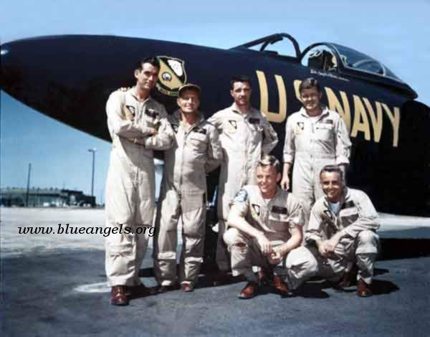 17 April 2010 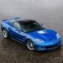

1953 Blue Angel Team 2009 ZR-1

Sponsored by the Miracle Strip Corvette Club www.miraclestripcorvetteclub.org

Show Sponsors:

LEO’S CORVETTES (850) 455-VETT ADVANCED INSURANCE (850) 469-0880
TRUSS ME MANUFACTURING 850-537-6250

Local Hotels: Ashton Inn & Suites, 910 N. Navy Blvd (850) 455-4561 (Outside Main Gate)
Or on the Web @ www.AshtonInnSuites.com

MILITARY PERSONNEL: You can call 1-800-NAVY INN to make reservations on base.
$20.00 Donation at registration will benefit the National Museum of Naval Aviation

Registration: 9am – 10am, Corvette Show: 10am – 2pm

Dash plaques will be presented to the first 100 participants and trophies will be
Awarded to the Top 30 Corvettes Registered at the Show.

REMEMBER: VALVE COVER CAR RACES

Show will be held at the Naval Air Station Pensacola, Pensacola, Florida, at the
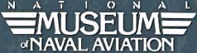
(Adults will need to present a picture ID for entrance to the military installation.)
For more information contact Leah Pittman @ 850-572-7402 or leahsc6@bellsouth.net

NAME:

ADDRESS:

PHONE: _________________________________________

Club Affiliation: _____________________________________________________________________

EMAIL ADDRESS: ___________________________________________________________________________

Year: Coupe: Conv: Color: ZO6:____ Color: _____________

GS: Year: ______ Coupe: ___ Conv: ___Color _______________ ZR1: ____ Color: _____________
Valve Cover Car Rules:

1. Small block Chevy valve covers only (no ZR1 cam or any other cam covers)
2. Gravity race - no propulsion of any kind!
3. Maximum weight: 8 lbs. (Official scales at race site prevail!)
4. Maximum width: 10.5 inches (outer tire edge to outer tire edge)
5. Maximum tire diameter: 4 inches
6. Maximum number of tires per vehicle: 4
7. Tires shall NOT exceed beyond the length of the actual valve cover
8. Weights must be fixed - no moving parts except wheel rotation; no liquid- filled weights
9. No cheating!!
All entries welcome! Trophies will be awarded for 1st, 2nd, and 3rd places.

RELEASE AND WAIVER OF LIABILITY
Your signature on this entry form indicates that you cannot, in any way, hold the Miracle Strip Corvette Club (a non-profit organization), officials, members, The National Museum of Naval Aviation, the U.S. Navy and/or other participants liable for any losses and/or damages that occur during this event. In consideration of the acceptance of the right to participate, entrants, participants and spectators agree to hold harmless the said club, museum and U.S. Navy and its officials from any claim for loss or liability for injury to or death of any person or persons (including the undersigned) or damage to any property arising out of or in any way related to said event. This release and waiver shall be binding on the heirs, executors, administrators, and assignors of the undersigned. Your signature also permits use of your name and pictures for publicity or advertising without remuneration.

Driver Signature: Date:

